GUI – Dalmia Cement, New Delhi

Step 1 – Connect the Ipad ( touch controller) in same wifi range.

Step 2 – Open browser, e.g. Safari in Ipad ( touch controller) , type the ip address http://192.168.0.11/Interface/.

Step 3 - After that , Welcome page is come, than press “Tap to Begin”.


Step 4 - After that , Loading page is come, than wait for around 1 minute.


Step 5 - After that , Mainpage is come, here the features / navigation that we can perform.
- Town Hall – In this we can perform Teams meeting, Wireless content share, DTH TV and HDMI content share through laptop.

- Device Control – Here we can Turn ON / OFF the Display 1, Display 2, Display 3.

- Shutdown – It can shutdown the program.

- Back - After click the Back button it navigate to the pevious page.

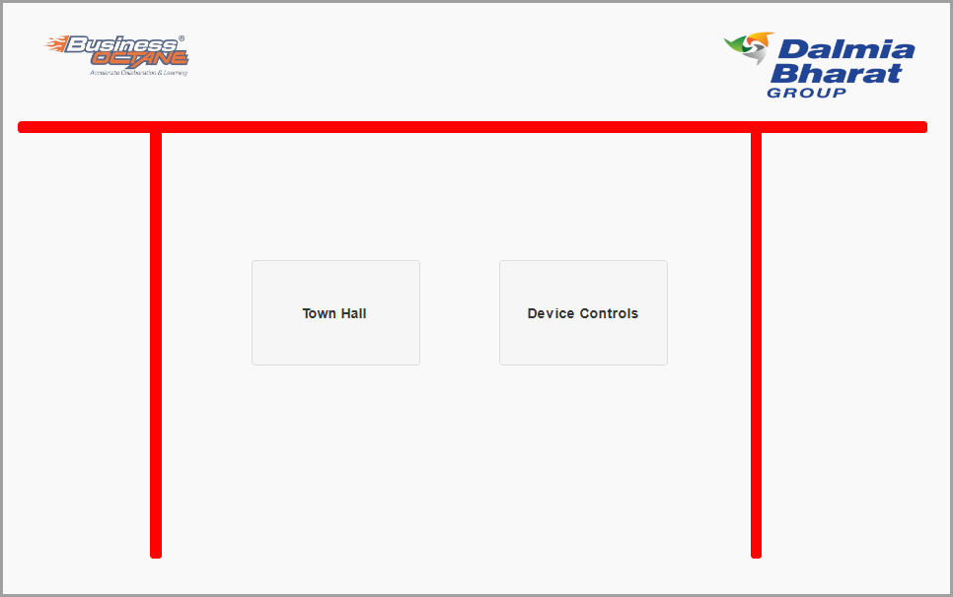

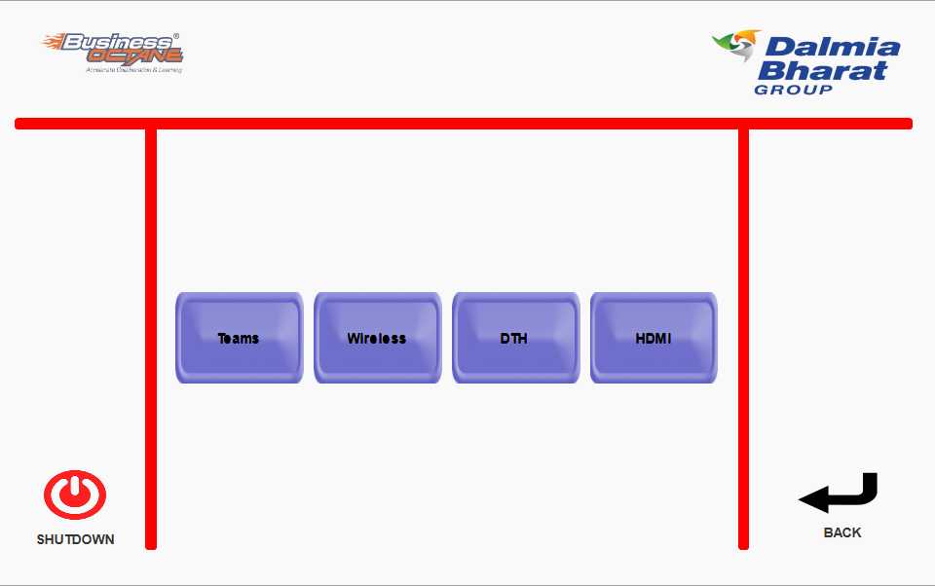

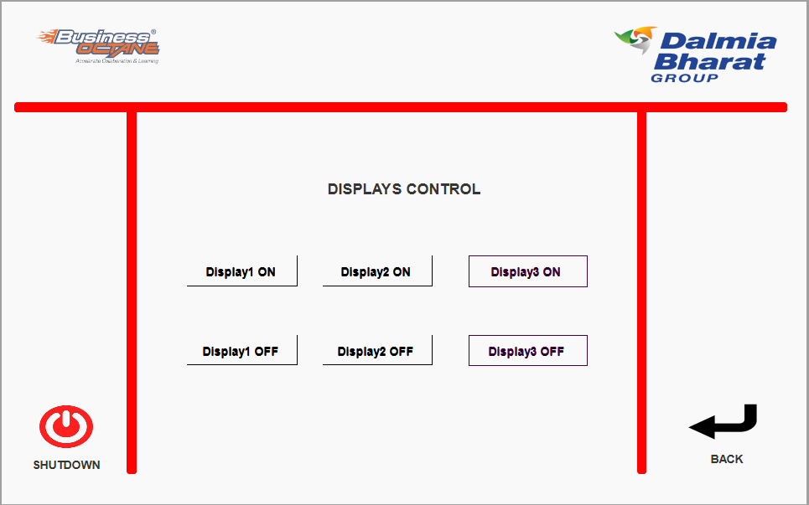

Step 6 - In Shutdown mode, we can Shutdown the all system.

